**LAB# 2**



**Fall 2023**

**COA Lab**

**Submitted by**: **Abdul Rasheed**

**Registration No**: 21PWCSE2063

**Class Section**: **B**

“On my honor, as student of University of Engineering and Technology, I have neither given nor received unauthorized assistance on this academic work.”

Student Signature: ______________

Submitted to:

**Dr. Bilal Habib**

**Department of Computer Systems Engineering**

**University of Engineering and Technology, Peshawar**

**BRANCHING OPERATION:**

Q NO 1: Enter a number 5432 from user and then display the last digit in the console. (hint: use mfhi ).

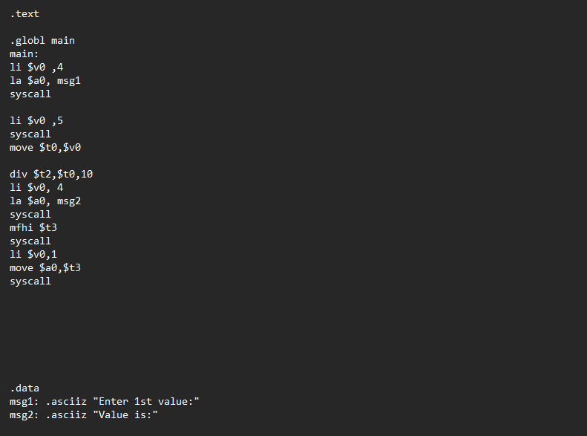

Output:

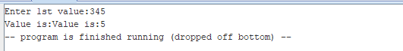

Q NO 2: Check whether a number input by user is negative or equal to zero or greater then zero using branching ( Use bgt or ble ).

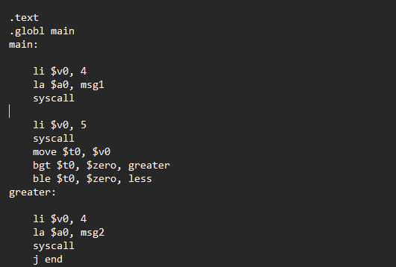 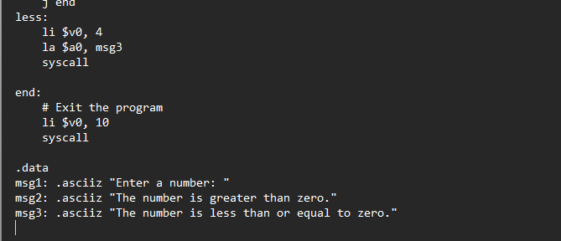

Output:

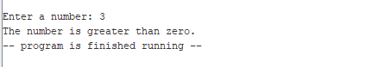

Q NO 3: Check using branch whether the number input by user are equal or not ( Use beq ).

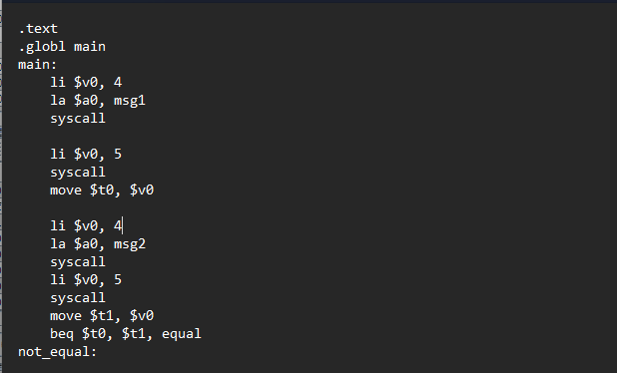

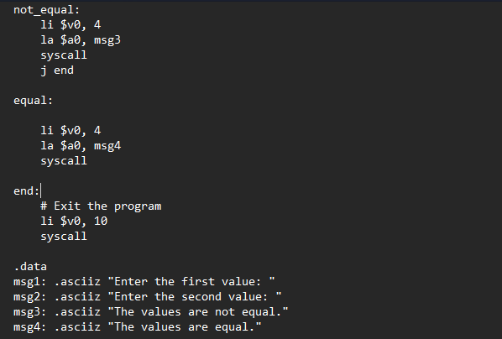

Output:

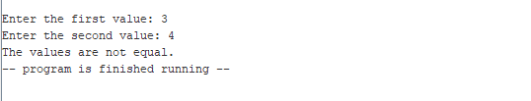

Q NO 4 : Write the assembly of the below C++ code.

Int age;

Cout<<”enter your age”<<endl;

Cin>>age;

If(age > 18)

{

Cout<<”you can apply for CNIC”<<endl;

}

Else

{

Cout<<”you cannot apply for CNIC”<<endl;

}

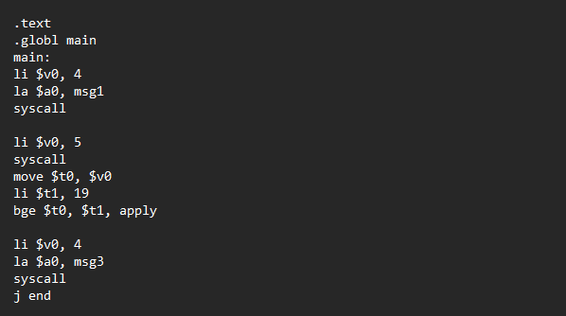

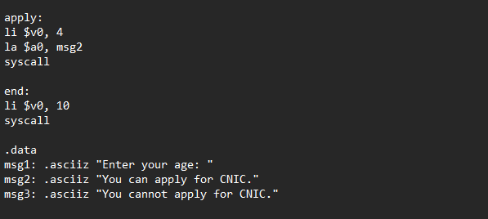

Output:

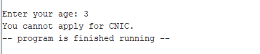

Q NO 5: Write a program which take a limit from user and compute the sum of numbers from 0 to the limit ( Use bqe, add, addi, and J (jump)).

Below is the C++ language code:

Int limit; Int sum;

Cout<<”Enter a number”<<endl; Cin>>limit;

for (int i = 1; i <= limit; ++i) { sum += i; }

Cout<<”sum of numbers from 1 to <<limit<<”is”<<sum<<endl;

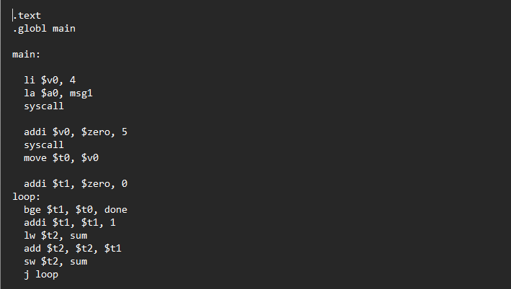 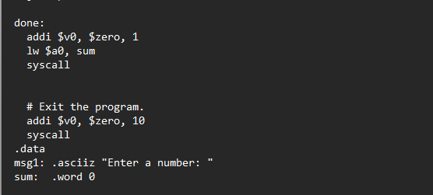

Output:

